Dear [Wellbeing / HR Lead],

I am writing to make you aware of a mental health and suicide prevention resource from a charity called R;pple which is available as an additional layer of protection and support for our staff across [Your company name] and available to download immediately.

Why is this important?
- Searches for suicide methods have increased by 50% in the last 2 years (SEMrush, 2021)
- Searches for suicidal thoughts have increased by 23% in the last 2 years (SEMrush, 2021)
- Searches for suicide helplines have increased by 125% since January 2019 (SEMrush, 2021)
- Male suicide is at it’s highest rate in 20 years in 2020 (ONS)
- Harmful internet use was found in 26% of deaths in under 20s (Samaritans)

The background of R;pple
R;pple Suicide Prevention was founded and established as a charity in May 2021 by Alice Hendy. Alice lost her only sibling, her brother Josh, on 25th November 2020 to suicide at 21 years old. Josh had been researching techniques to take his own life via harmful internet searches. To ensure more help and support is given to individuals searching for harmful content online, his sister set up R;pple Suicide Prevention.

What is R;pple?
R;pple is a browser extension, which if a user searches for harmful content online, they will first be guided through a filter of breathing exercises and then very simple, uncluttered and calmly presented strategies and forums, help lines and mental health services they can access both now and longer term: accompanied with messages of hope and encouragement to keep safe. R;pple works seamlessly with current firewalls in place and provides individuals with a subtle intervention of hope and support when they are at their most vulnerable point.

What impact has R;pple made?
- Since launching in September 2021, R;pple has been downloaded over 1.9 Million times.
- R;pple has intercepted over 70,000 genuine harmful online searches.
- Although R;pple does not collect any personally identifiable information whatsoever,
31 individuals have approached the charity directly to inform them that R;pple has saved their life.
- R;pple is available to be tailored to your organisation, for example by signposting to your internal Employee Assistance Line (EAP).
- R;pple is available in multiple languages around the world
- R;pple has won 34 awards in the mental health and innovation space.
- Businesses who have already installed R;pple include West Ham United FC, RPC Law, QBE Insurance, Lockton Insurance, Manchester Airport and Save the Children.

How much does R;pple cost?
- Deploying R;pple starts as low as 25p per computer, a full breakdown of costs can be found here
- A 50% discount is available for all Public Sector organisations (including Local Authorities, Integrated Care Bodies (ICB’s), Fire & Rescue, Police Forces, Libraries, Local and Central Government)

Thinking about the challenges this might bring?
Take a look below:

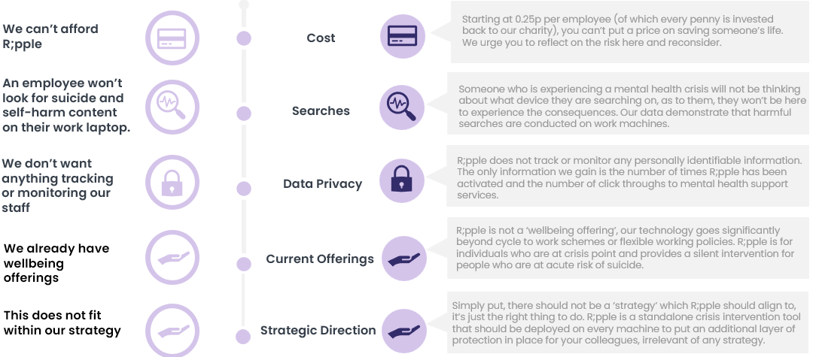

Who should I engage to deploy R;pple across my organisation?
- Wellbeing teams
- IT departments

Useful Links
- Download R;pple on Chrome / Edge / Firefox / Opera / Safari
- Explainer video & R;pple Demo

How to download R;pple
- Individuals, Parents and Guardians - download R;pple at home, for free, here
- Businesses and corporates - liaise with your Wellbeing and IT teams and inform them that R;pple is a browser extension that can be deployed, en masse (FAQs)

I hope you can support me in my mission to get people the mental health support they need at a time when they are most vulnerable.

This resource is saving lives and will provide a subtle intervention if (or when) any of our colleagues are feeling so low that they conduct a harmful online search relating to self harm and suicide whilst at work.

Yours sincerely,

[Your name]
[Your contact details (if appropriate)]

